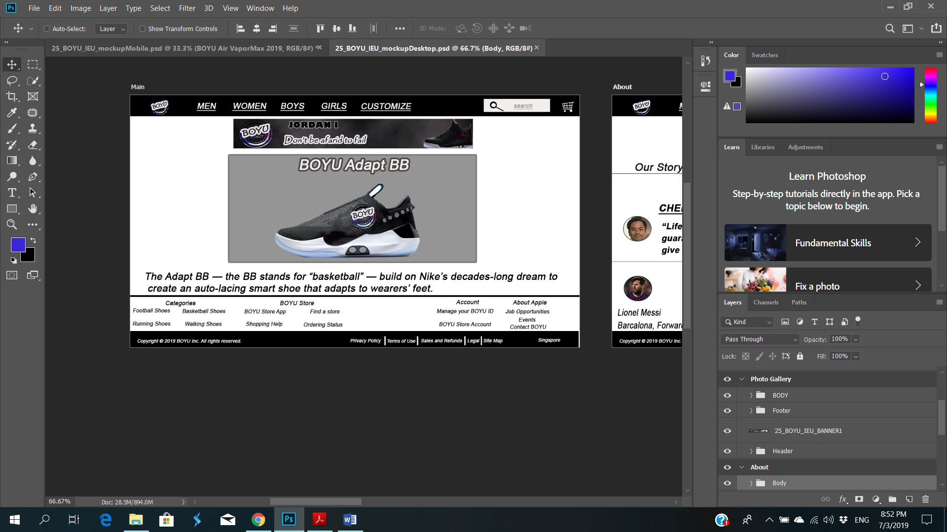**Report for Desktop**

* Usability

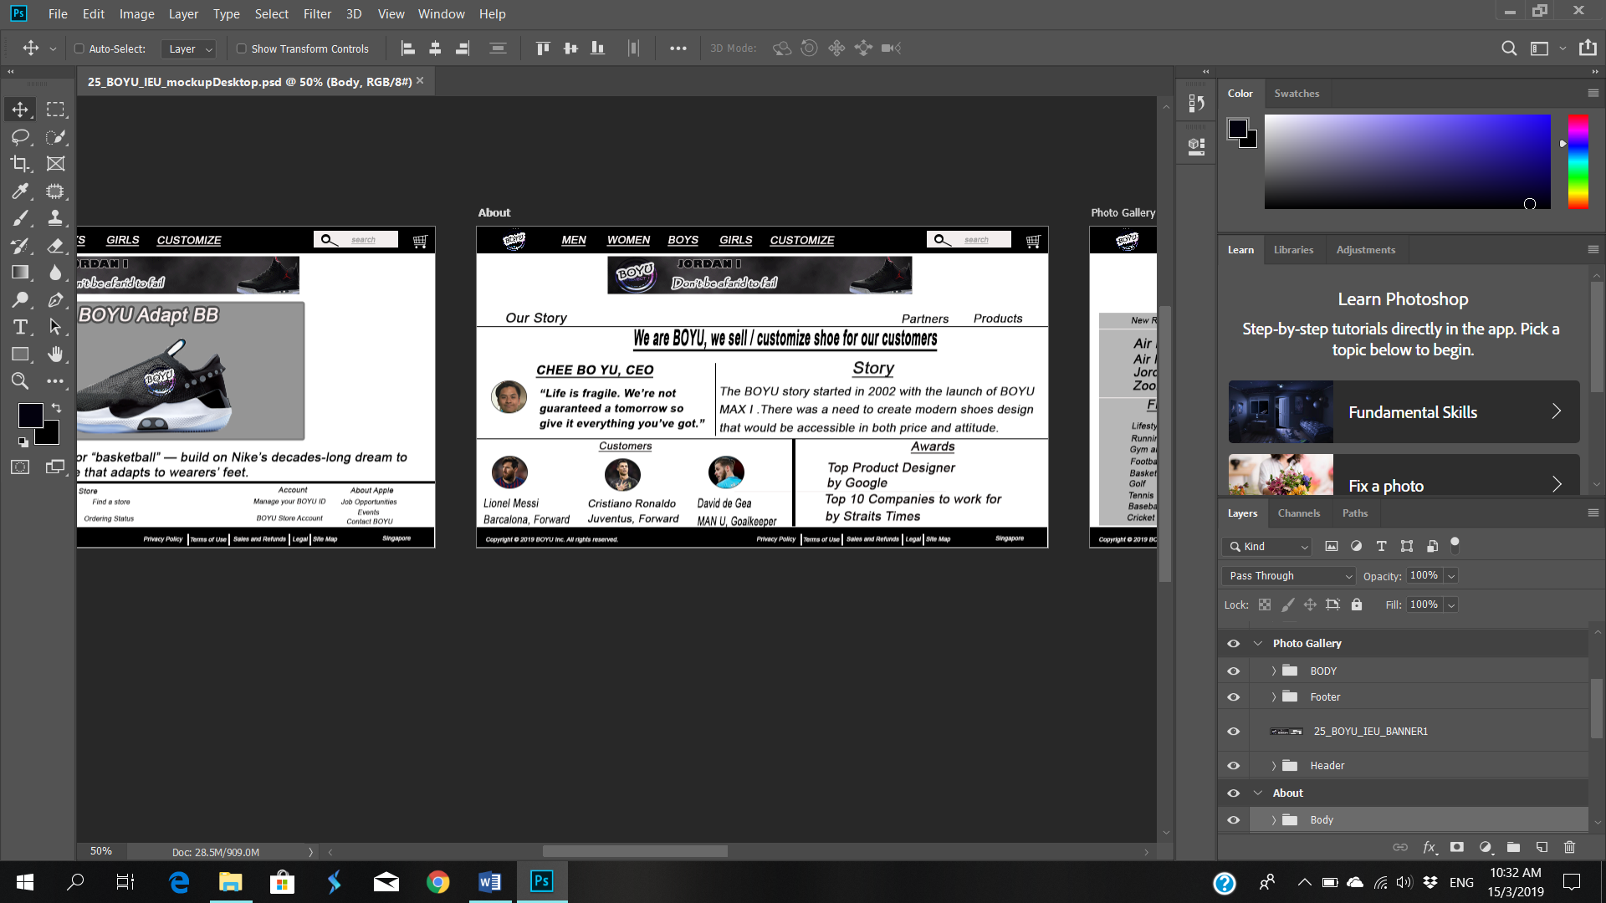My Webpage is easy to use because it has a menu bar and search bar for the visitor to navigate, does not have unnecessary text on the page which made it easier to read and also the content is well organized because has bold / underlined text to let the visitor know that it is a title and lastly my webpage has some whitespace to keep the visitor focused on what the important details, and doesn’t overwhelm with too much information.

* Accessibility

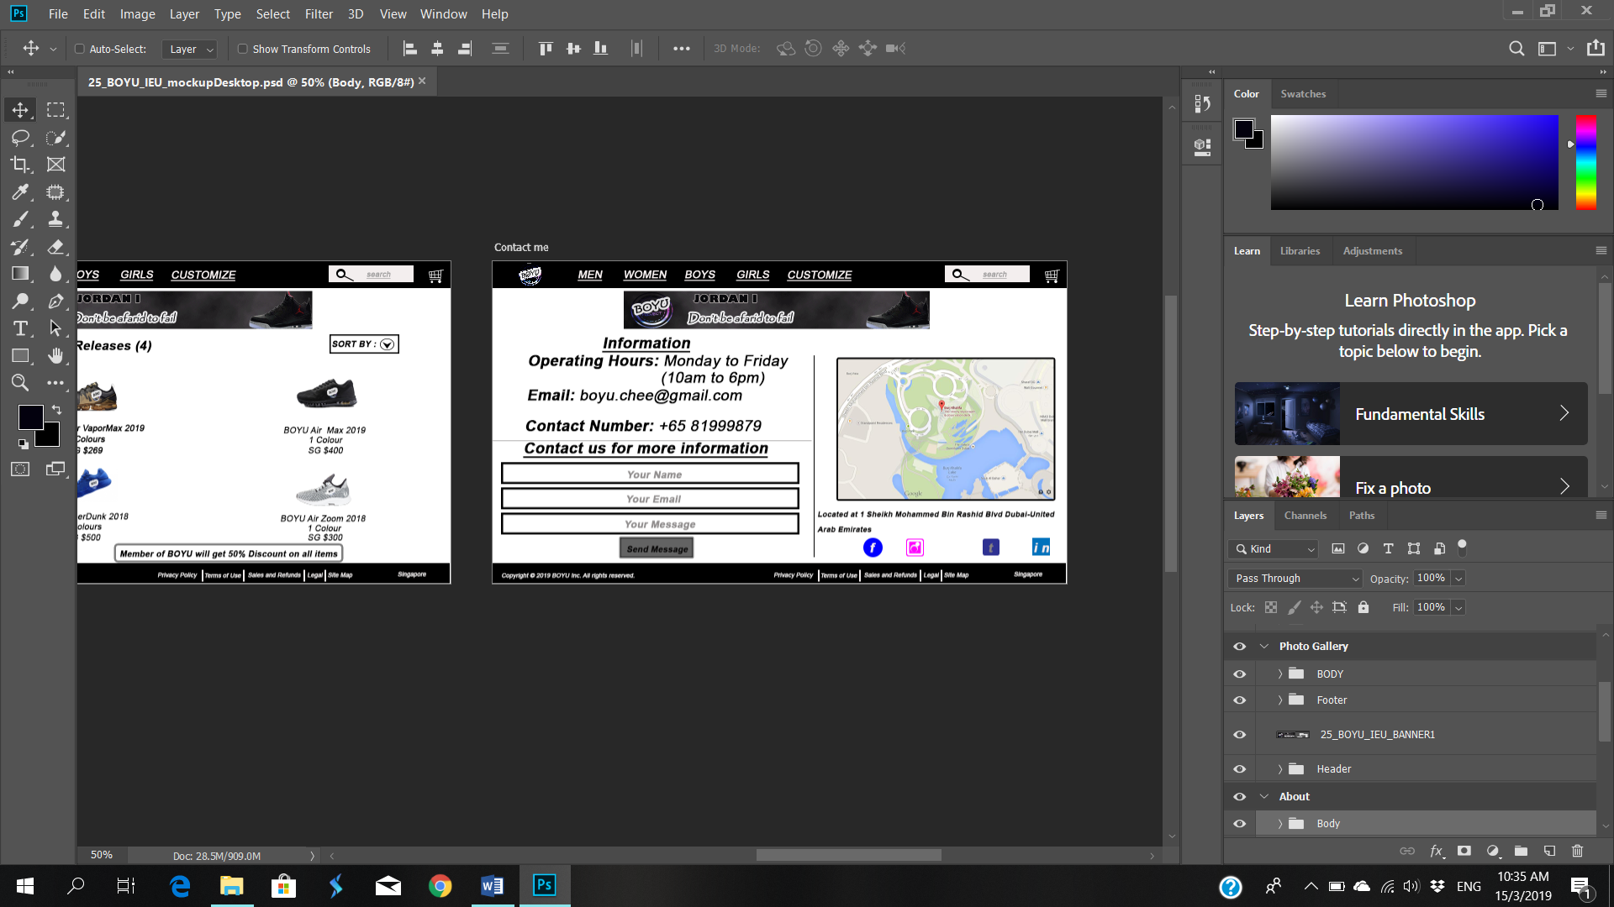My Webpage uses the same font and button for the visitor to navigate my webpage, offer choice such as Men, Women, Boys, Girls, customize, filter for the visitor to what they want or choose for their preference. My webpage also has information for the visitor to know and the visitor can send me an email to find out more information and have a cart for the visitor to check what they have added to the cart

* Consistency

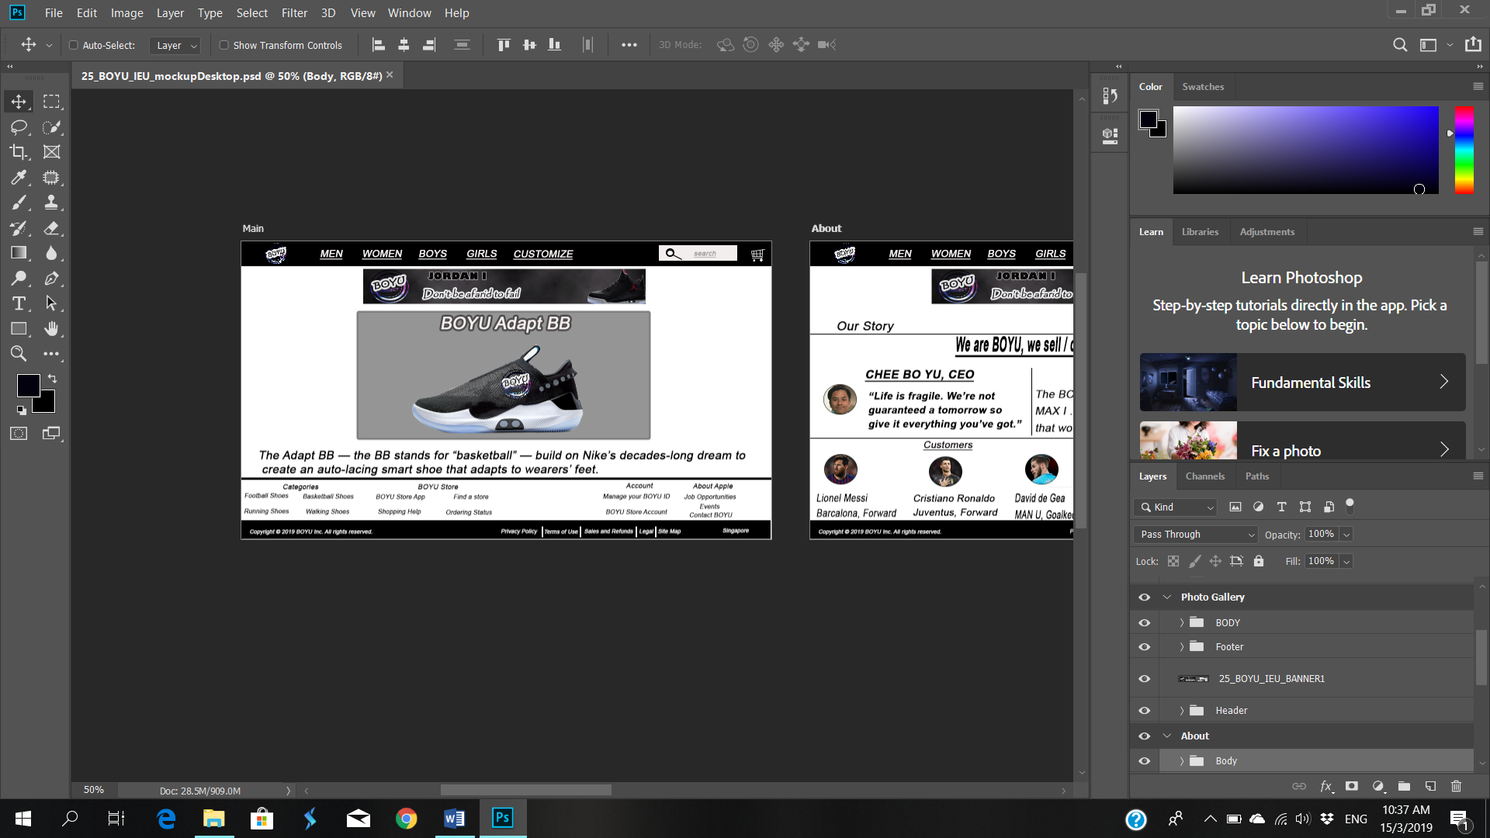The banner, header and footer have appeared in the same position throughout the webpage. The textual elements are evenly aligned and the font type is the same throughout. The colour is consistent throughout the page. The search bar has the same spot throughout the webpage and it is easier for the customer to find.

* Predictable

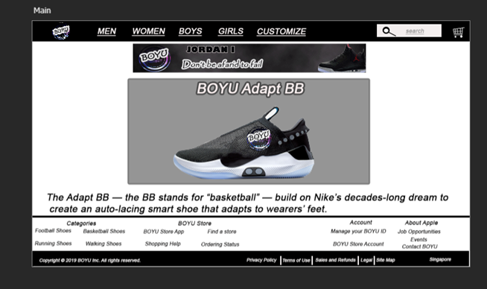I use simple and basic interaction for the webpage so that user will know how to navigate the webpage, example a search bar for the customer to find what they want on my webpage, a shopping cart for the customer to bookmark the product they want to buy in my webpage.

* Visibility

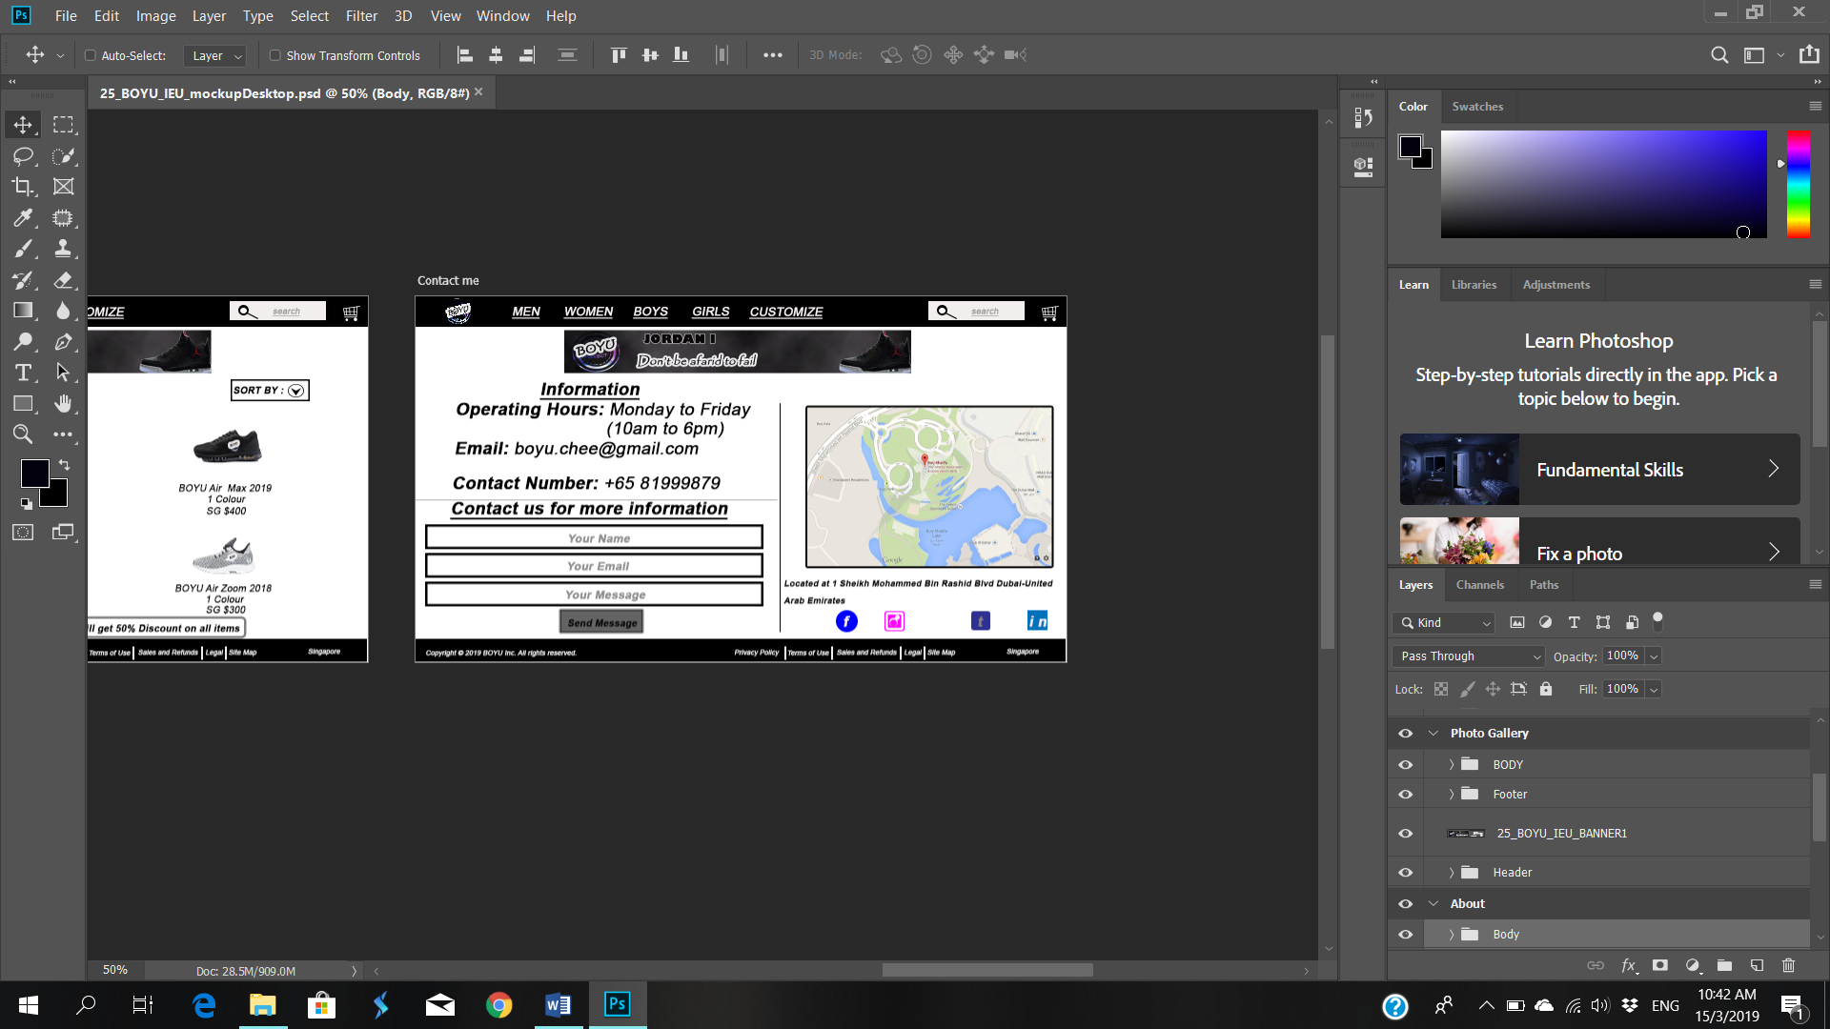My webpage has obvious UL control such as the send message is visible and accessible for the visitor to click and social media icons such as Facebook, Instagram, Linkedin and lastly Twitter for the visitor to find out more about the company. There is no hover for touch screen but when the customer click or press will have a hover effect.

* Learnable

My webpage has a simple interaction such as a Navigation Bar for the customer, next time the user visits my webpage is much easier to navigate or know what to do.

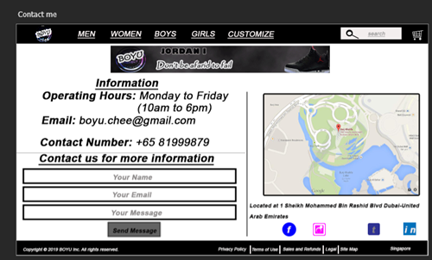

* Feedback

My webpage has sent a message for visitor ask a question if they have any enquires, how to improve the webpage design or if there any error on the webpage which is not clickable and also sends message button to be enabled to send a message to me

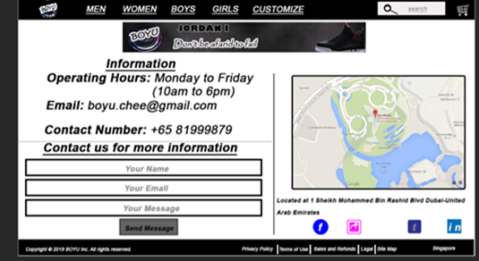

* Visual Design

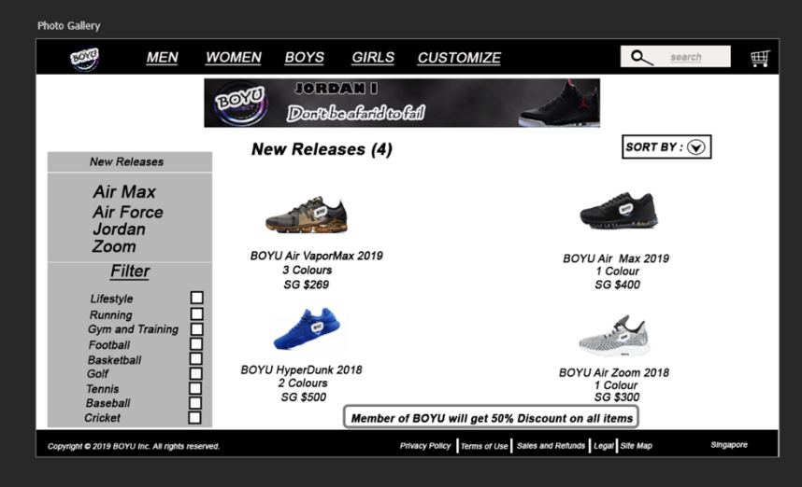I use Lines to use it as a divider to separate the content in my about page, also uses the square box to check what they want by ticking the square box for my photo page.

